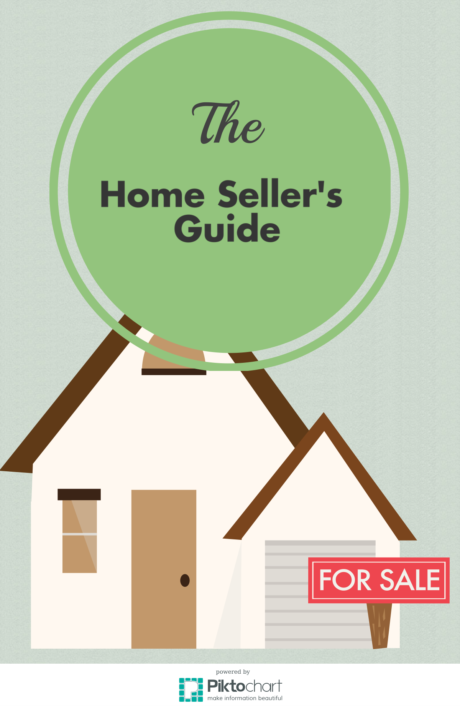
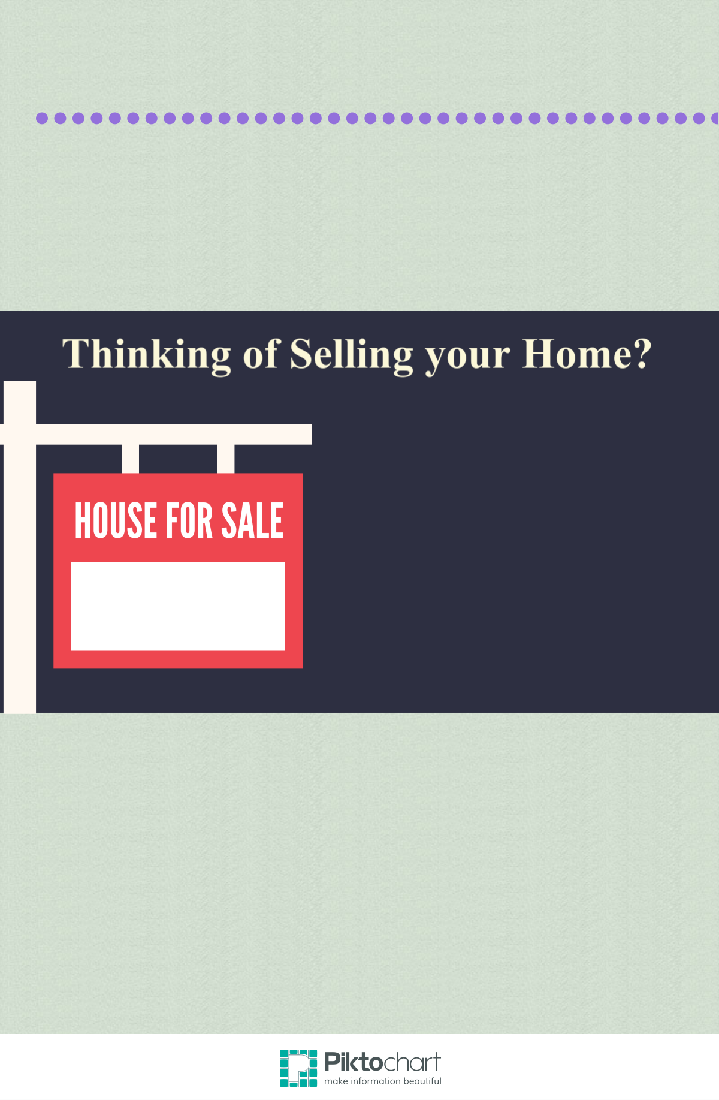
Why work with me?
Or are your curious about the value of your home?

Great! I’m here to help you with every stage of the process so you can make the best choice for you and your family.

When selling homes, I use innovative marketing and listing strategies that are proven to sell your home for XX% more than anyone else. That means, on average, my sellers walk away with $X,XXX more!
+$X,XXX
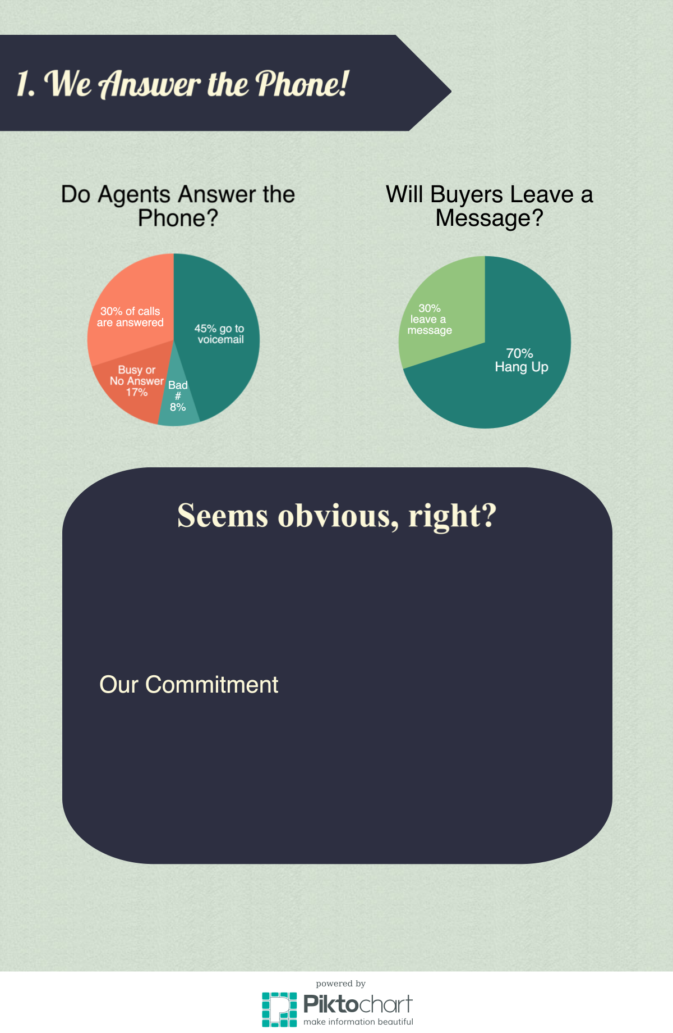
At least, it should be! The graphics above, however, show just how many calls go unanswered.

Ultimately, this means 7 out of 10 buyer calls go unanswered, which can potentially cost you a quick deal and lots of money!
I’m dedicated to returning calls within five minutes. No potential buyer will go unanswered!

Whether it’s myself or another team member who answers the phone, buyers will speak with a high caliber real estate professional who knows exactly how to get them in your home!
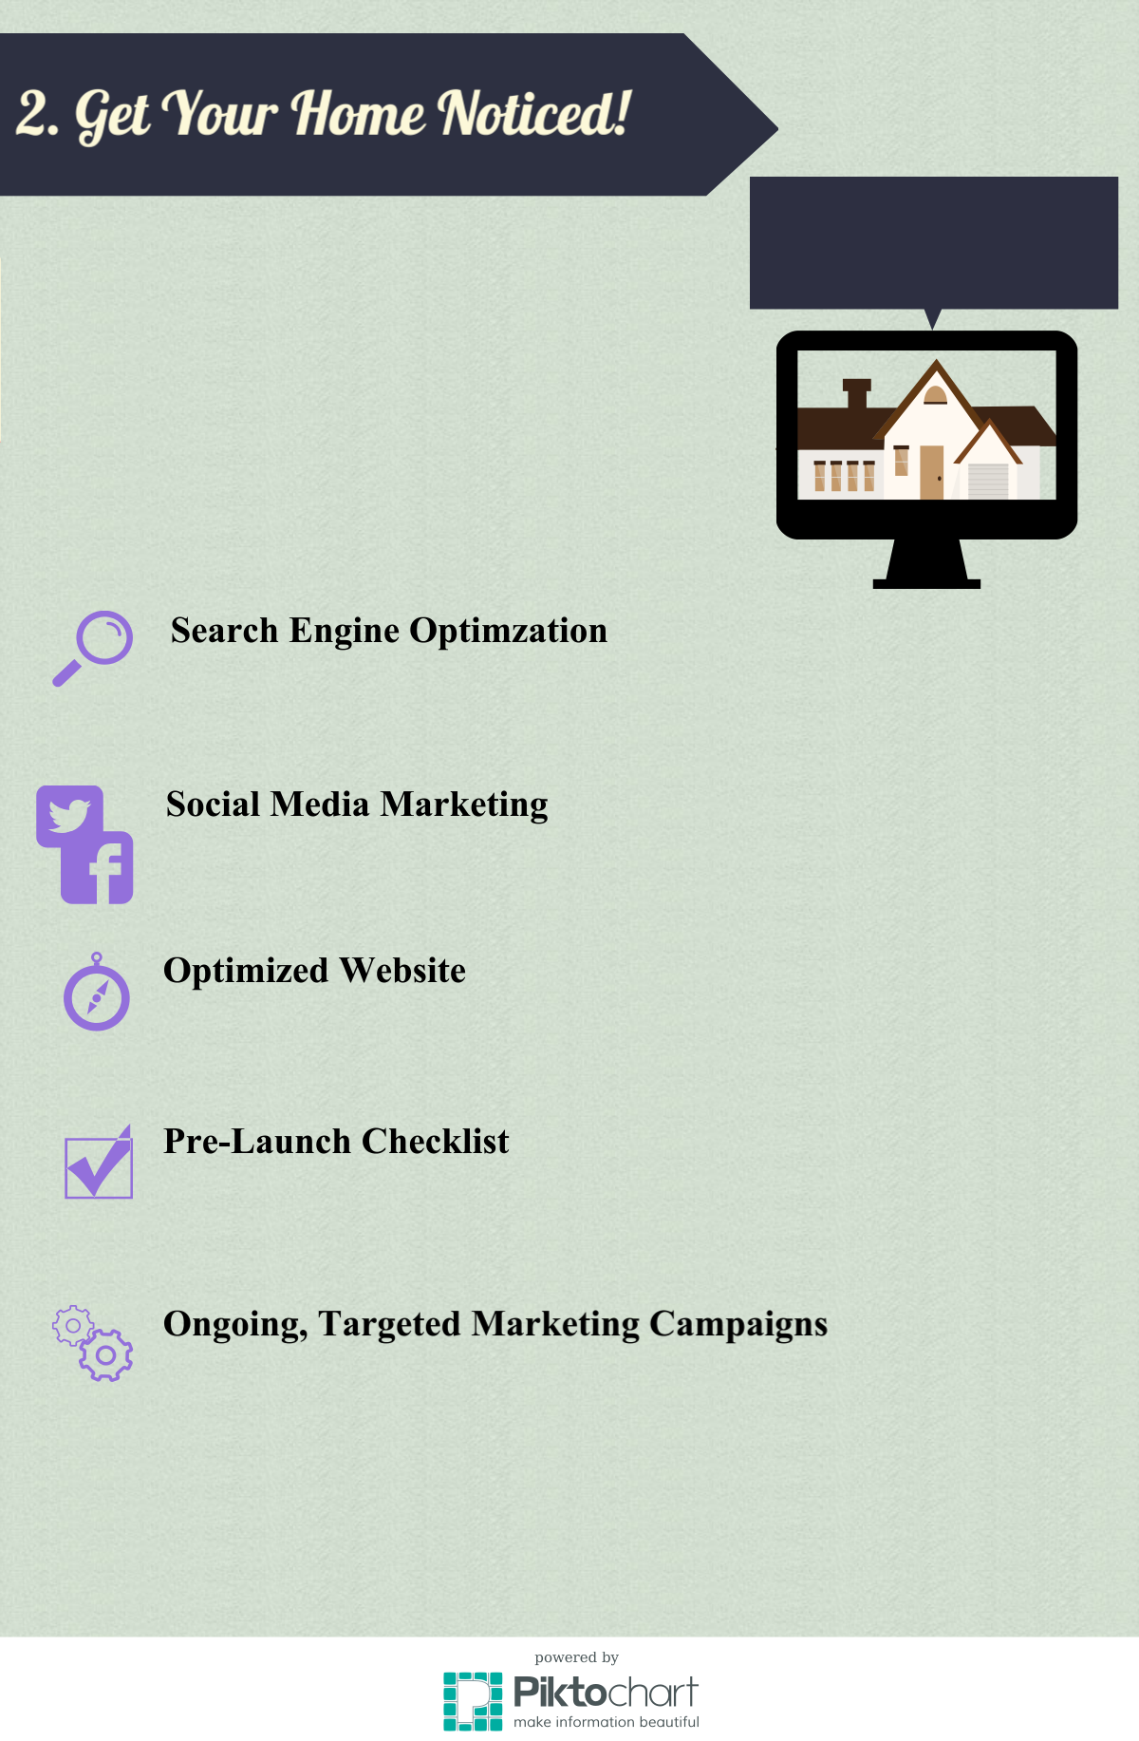
I’m dedicated to keeping up with the latest internet marketing techniques so the marketing for your home is seen more often and by more people!

I believe that advertising should put your home in front of as many of the right buyers as possible (so it sells quickly and for more money!)

That’s why I spend time and money every month to advertise and promote your home on all of the best channels. Take a look at just a few of my unique internet marketing strategies:
Homes listed with me are viewed online more often!
I make sure your home shows up first. In fact, even my photos are optimized to be found on Google and to direct buyers to your property online! Just Google the address of any of my current properties for sale and see where I rank!
Your home will be promoted with the latest marketing techniques through Twitter, Facebook and YouTube. You can view my Facebook Business Page at facebook.com/XXXXXXX!
My website is specifically designed to engage visitors. From the overall layout to its unique, informative content, my website will guide potential home buyers to your home!
Once a listing agreement is in place, I conduct a series of activities to intentionally drive traffic to your home on my website and improve our SEO (search engine optimization) so your home shows up on the first page of results!
After staging your home and establishing it online, we conduct a series of targeted marketing campaigns across social media and other channels to continually drive qualified, interested buyers to your property!
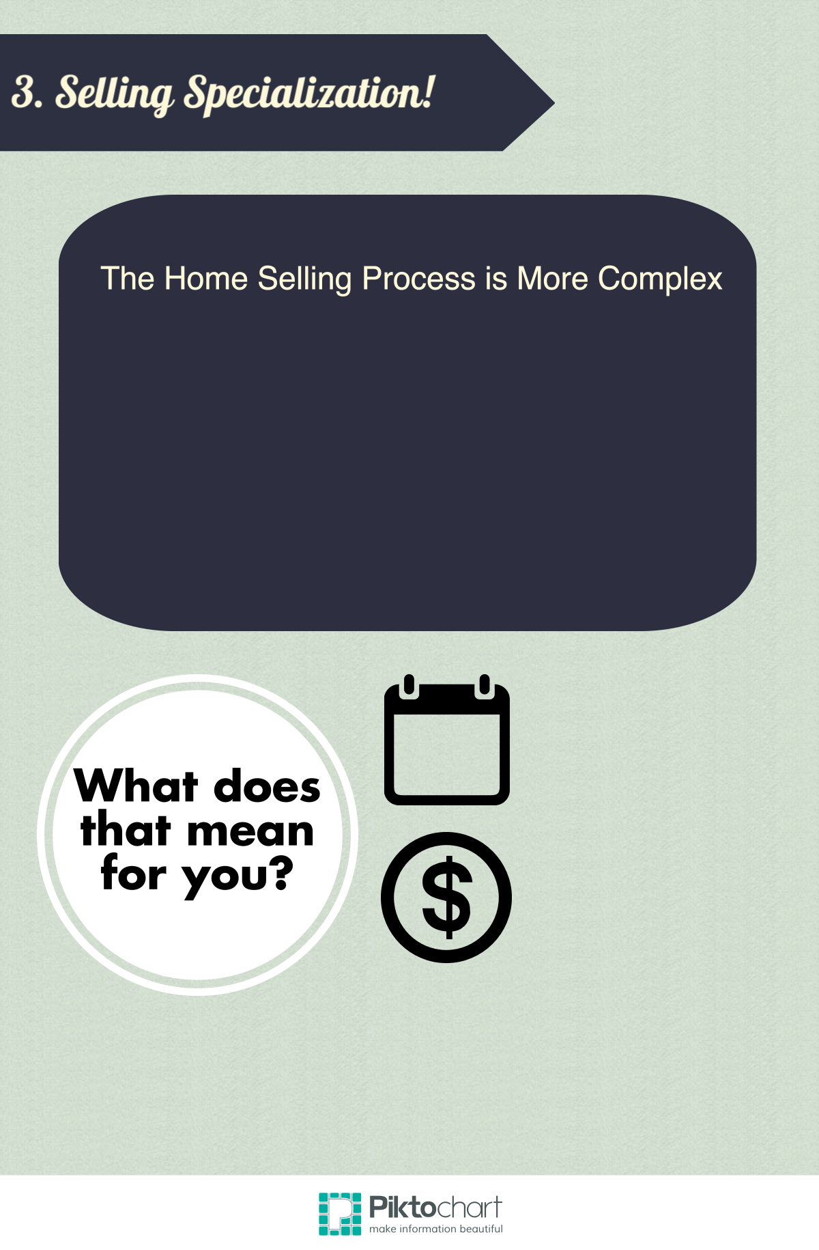
Today, the home selling process is much more complex than it was ten years ago. Think about it - ten years ago, YouTube, Facebook, and Twitter were brand new and incredibly small!

Because it takes more to sell a home today, it takes an agent who is 100% dedicated to staying on top of the latest marketing strategies, local market, and larger national trends to ensure your home sells fast and for the most money possible.

Your home will sell faster. I sell homes, on average, XX days faster than other brokerages!
XX
Your home will sell for more!
I currently sell homes for XX% more than average!
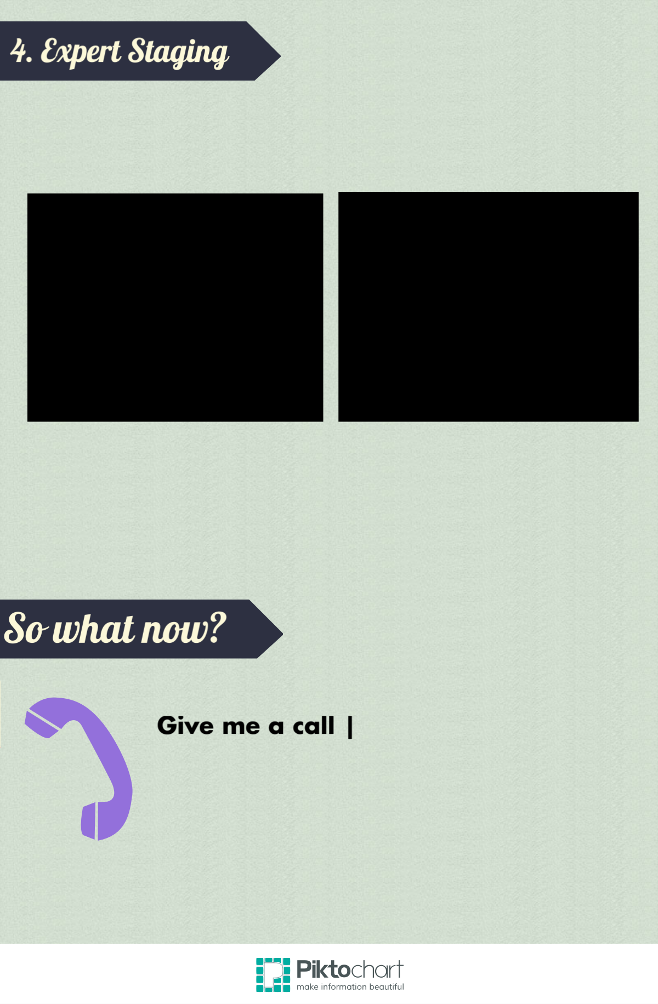
Most buyers are looking for homes that are "move-in" ready, and they use photos to decide which properties should be on their must-see list. This makes staging your home one of the most crucial parts of the home selling process.
What's more, your home is competing against model homes that have thousands of dollars budgeted for professional staging and cleaning.

I work with a full suite of trusted vendors, professional stagers, make-ready repair teams, and photographers to ensure that your home shows its very best, both online and when buyers walk through the door!
XXX-XXX-XXXX
If you are considering selling your home, give me a call at XXX.XXX.XXXX. We would love the opportunity to learn more about your specific situation and help you sell your home!

